NAME 338

Ship Design Project and Presentation

By

STUDENT NAME

Student ID: 12344567

Submitted to the

Department of Naval Architecture and Marine Engineering, Bangladesh University of Engineering and Technology,

In partial fulfillment of the requirements For the degree of

BACHELOR OF SCIENCE

In

Naval Architecture and Marine Engineering



October 2024

Department of Naval Architecture and Marine Engineering, Bangladesh University of Engineering and Technology, Dhaka-1000, Bangladesh

# 

# Forwarding Letter

To,  
The Course Supervisor,  
Name  
Professor,  
Department of Naval Architecture & Marine Engineering, BUET  
Subject: Submission of report on project title

Dear Sir,  
We are very grateful to you for giving us the chance of submitting the report. We  
tried to make a useful report on “Project Title”. For preparing the report we have studied a lot. Also, we took support  
from different books, respected teachers of our department and also internet.  
We are thanking you for all your help as our  
supervisor in completing the assignment. And if there is any mistake, we hope  
that we will have your forgiveness and kind consideration.  
Sincerely yours,  
Name  
Student No:   
&  
Name:  
Student No:   
Level- Term-  
Department of Naval Architecture and Marine Engineering, BUET.

Table of Contents

Forwarding Letter ⅰ

Preface 1

Objective 2

1 Introduction 3

2 Owner Requirement 4

3 Route specification 5

4 Objective Of The Ship 6

5 General Features Of Ship 7

6 Basis Ship Ship 8

7 Preliminary Calculation 9

7.1 Determination of preliminary principal particulars 9

7.2 Final principal particulars 9

8 General arrangement plan 10

8.1 Section 1 10

9 Lines plan 11

10 Hydrostatic calculation 12

10.1 Section 1 12

10.2 Section 2 12

10.3 Section 3 12

10.4 Section 4 12

10.5 Section 5 12

11 Scantling calculation 13

11.1 midship section drawing 13

11.2 longitudinal construction 13

11.3 Shell expansion 13

12 weight calculation 14

12.1 Section 1 14

12.2 Section 2 14

12.3 Section 3 14

12.4 Section 4 14

13 Stability calculation 15

13.1 Section 1 15

13.2 Section 2 15

14 Trim calculation 16

14.1 Section 1 16

15 Resistance and power calculation 17

15.1 Section 1 17

15.2 Section 2 17

16 Rudder calculation 18

16.1 Section 1 18

16.2 Section 2 18

17 Steering arrangement 19

17.1 Section 1 19

17.2 Section 2 19

18 Engine selection 20

18.1 Section 1 20

19 Gearbox Selection 21

19.1 Section 1 21

20 Engine foundation scantling 22

20.1 Section 1 22

20.2 Section 2 22

21 Propeller design 23

22 Shaft arrangement 24

22.1 Section 1 24

22.2 Section 2 24

LIST OF TABLES

Table 1: Principal particulars 9

LIST OF FIGURES

Figure 1 : General Arrangement Plan 10

# Preface

Provide a brief overview of the purpose and context of this document, including background information relevant to the project.

# Objective

# 

Clearly state the primary objective of this project or report, including the goals and intended outcomes.

# Introduction

# 

Insert text here

# Owner Requirement

Insert text here

# 

# route specification

Insert text here

## OBJECTIVE OF THE SHIP

Insert text here

# GENERAL FEATURES OF SHIP

Insert text here

# BASIS SHIP SELECTION

Insert text here

# PRELEMINARY CALCULATION

## 7.1 Determination of preliminary principal particulars

Detail the main dimensions and characteristics of the vessel, such as:

* Length Overall (LOA)
* Beam
* Depth
* Draft
* Deadweight

## 7.2 Final principal particulars

Table 1: Principal particulars

| **Principal Particulars** | **Unit** | **Value** |
| --- | --- | --- |
| Length Overall (LOA) | m |  |
| Length Between Perpendiculars (LBP) | m |  |
| Beam (Breadth) | m |  |
| Depth | m |  |
| Draft | m |  |

# 8 General arrangement plan

Insert text here

## 8.1 Section 1

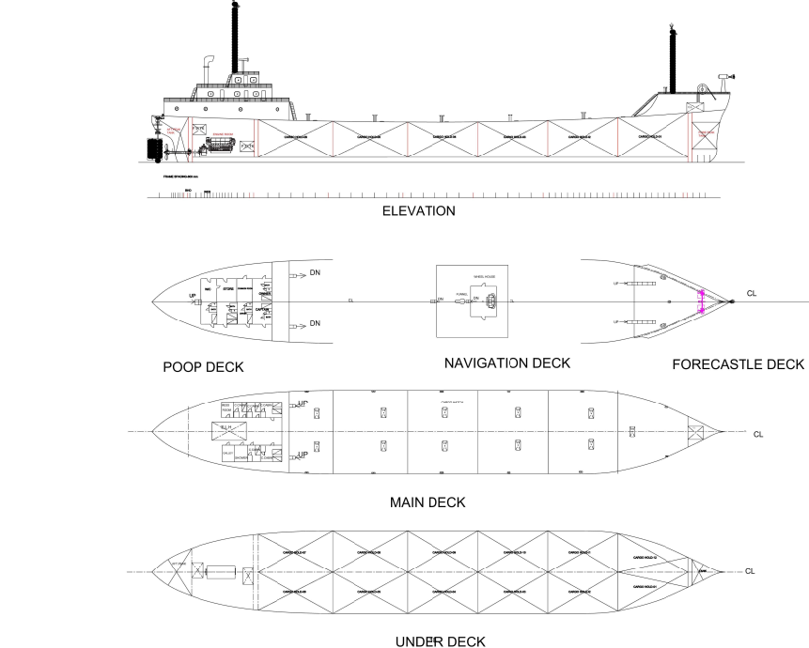

Figure 1 : General Arrangement Plan

# 9 Lines plan

Insert text here

# 10 hydrostatic calculation

Insert text here

## 10.1 Section 1

Insert text here

## 10.2 Section 2

Insert text here

## 10.3 Section 3

Insert text here

## 10.4 Section 4

Insert text here

## 10.5 Section 5

Insert text here

# 11 Scantling calculation

Insert text here

## 11.1 midship section drawing

Insert text here

## 11.2 longitudinal construction

Insert text here

## 11.3 Shell expansion

Insert text here

# 12 weight calculation

Insert text here

## 12.1 Section 1

Insert text here

## 12.2 Section 2

Insert text here

## 12.3 Section 3

Insert text here

## 12.4 Section 4

Insert text here

# 13 stability calculation

## 13.1 Section 1

Insert text here

## 13.2 Section 2

Insert text here

# 14 Trim calculation

## 14.1 Section 1

Insert text here

# 15 resistance and power calculation

Insert text here

## 15.1 Section 1

Insert text here

## 15.2 Section 2

Insert text here

# 16 rudder calculation

Insert text here

## 16.1 Section 1

Insert text here

## 16.2 Section 2

Insert text here

# 17 steering arrangement

Insert text here

## 17.1 Section 1

Insert text here

## 17.2 Section 2

Insert text here

# 18 engine selection

Insert text here

## 18.1 Section 1

Insert text here

# 19 GEARBOX SELECTION

## 19.1 Section 1

Insert text here

# 20 ENGINE FOUNDATION SCANTLING

Insert text here

## 20.1 Section 1

Insert text here

## 20.2 Section 2

Insert text here

# 21 propeller design

Insert text here

# 22 shaft arrangement

Insert text here

## 22.1 Section 1

Insert text here

## 22.2 Section 2

Insert text here